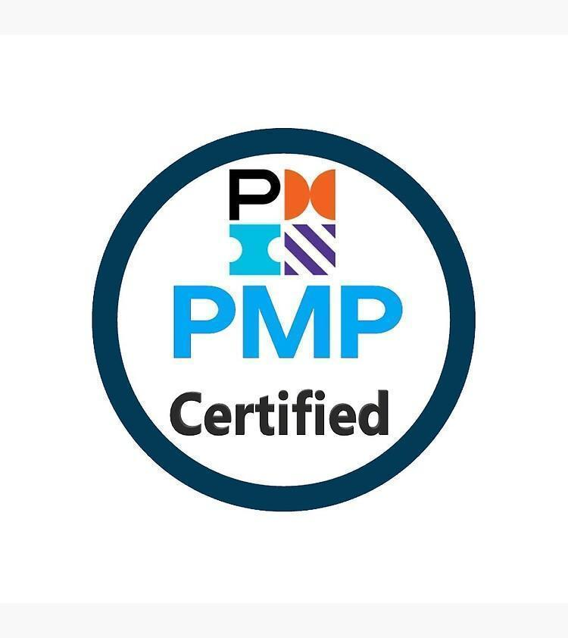
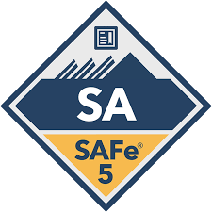


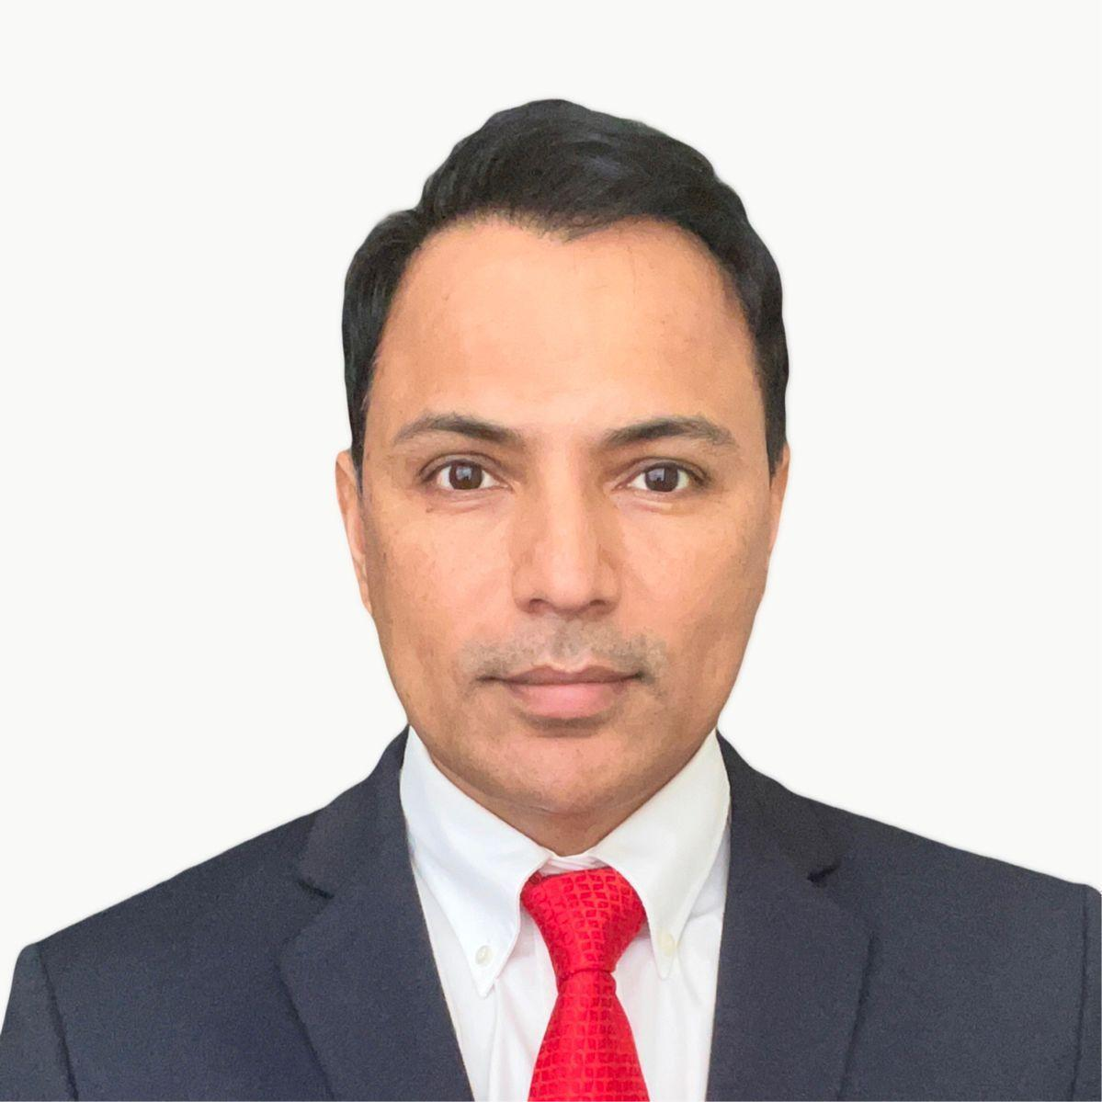
THAG ADHIKARI (Sr Project Manager – Technology )
Linkedin; E-Mail: adhikari77@gmail.com; Houston, TX; Phone: +1(917)971-9499

Senior Project Portfolio Manager & Governance Leader with 20+ years of experience managing enterprise technology
demand intake, SOX control governance, and portfolio operations. Proven track record delivering enterprise governance
frameworks, executive reporting, and cross-functional portfolio leadership across large-scale transformation initiatives.

Expertise in delivering modernization & cloud migration initiatives with core expertise in defining/set up of Managed
service agreements/support models of up to 25Mn USD for public & private organizations.

SUMMARY

- Hands-on Agile project manager overseeing cross-functional program governance & metrics for execution of all phases of enterprise-wise/ERP (Oracle, Microsoft Dynamics, Workday) & data standardization programs within complex, matrixed stakeholder environments.
- Proficient in agile, hybrid & waterfall methodologies to drive successful outcomes/go-lives for transformation ERP projects including data migrations, data integrations, AI/ML, Analytics & reporting.
- Experienced as a PMO-Governance & QA project manager in a shared services model managing executive portfolio reporting and dashboards.
- Managed intake & prioritization under shared services model. Build Project Charter, define the project scope, objectives, QA testing strategy and deliverables for large-scale, cross-functional technical programs across multiple workstreams concurrently
- Agile Coaching & Culture: Team Maturity Growth, Change Management (OCM), Continuous Improvement Practices
- Improved delivery efficiency by 20% by institutionalizing Agile ceremonies, Scrum of Scrums, and Inspect & Adapt workshops.
- Reduced systemic blockers by 30% through proactive dependency management and ART sync cadences.
- TPM & Scrum Master for Payment Analytics finance transformation initiatives looking for pain-points to provide business solutions
- Driving testing strategy and maintaining documentation standards across the organization/departments. Enforce stakeholder approvals for business requirement documents, technical/functional design documents, all testing documents, RTM (requirements traceability Matrix)
- PMO/ Governance setup, financial tracking & reconciliation, forecasting, demand management and maintaining gross margins. Ensured compliance and audit readiness for portfolio initiatives
- Primary point of contact providing strategic program status, translating complex technical information into clear, concise updates for executive, business, and engineering audiences.
- Working and communicating directly with sponsors & stakeholders ensuring SOX Compliance & Audit Readiness
- Develop and maintain project intake/documentations, including project plans, status reports, RAID logs, and SOX control change processes/change requests and dashboards tailored for executive and program leadership
- Coordinated proposals/RFP, contract negotiations, due-diligence, workshops and execution.
- Tools for the program
  - Planview / Smartsheet - Portfolio reporting & planning including Project Plans/Cutovers/RAID Log
  - ServiceNow - Demand intake & governance workflows. Support Metrics
  - Jira - Change tracking and governance
  - Confluence - Business requirements & Documentation
  - QMetry - Testing / Defect Management
  - Microsoft/SharePoint – Project Planning, Document/Repository
  - Power BI - Executive dashboards & portfolio reporting

WORK EXPERIENCE

November 2023 – Current |Program Manager (Technology & Demand) |Sysco, Houston, TX

Accountable for Technology portfolio & governance framework for 45Mn USD finance transformation and data
modernization program in a matrixed stakeholder environment organization. Proposed standardized governance and
intake process by enabling automation/workflows and reducing project intake timelines by 30%.

- Accountable for finance transformation program across the organization. Created and maintained detailed work plan and schedule for agile and waterfall projects
- Tracked, managed RACI and escalated all risks, actions/changes, issues and decisions in appropriate project RAID logs
- Facilitated all project change requests, demos and coordinate approvals
- Tracked all project financials (budget, actuals, forecast, earned value)
- Led & established iterative delivery using Agile & effective sprint planning sessions, daily stand-ups, sprint reviews, and retrospectives, promoting team ownership
- Defined & presented AI/ML/RPA solutions along with overall project plans, project charters while maintaining detailed work plan and schedule for agile & hybrid projects
- Facilitated PI Planning and Inspect & Adapt workshops across distributed teams, aligning sponsors, Product Owners, and delivery teams on shared outcomes.
- Established program-level dashboards and Agile metrics to enhance transparency for sponsors and stakeholders.
- Proposed and presented PowerBI and Smartsheet dashboards for consumption of business leads enabling data‑driven decision‑making. Secured additional funding for modernization initiatives
- AWS Migrations & Implementation of Microsoft Dynamics 365/Vertex/Workday
- Managed intake, triage, prioritization, and approval workflows. Also supported presentation of project charters, project plans while maintaining detailed work plan and schedule for agile & hybrid projects
- Partnered with Finance & business leads driving ERP workstreams in Workday, Microsoft Dynamics & SAP for demand planning and to execute large implementation programs; data integration & analytics, conversions & migrations in alignment with Business leads, third-party vendors including functional implementation partners (Deloitte) & system integration partners.
- Incubated new Strategic Digital Transformation in finance space, encompassing the implementation of Analytics, Machine learning & Robotic Process Automation. Reduced modernization timelines for “build-phase” by 40%
- Managed cross-functional governance across IT, Risk, Finance by developing clear, concise program documentations like user guides, testing strategy (UAT/System test cases), traceability matrix, RAID logs, communication plans, and executive dashboards.
- Created & facilitated cutover, go-live planning, stage‑gate reviews & approvals across milestones ensuring alignment with PMO
- Stake Holder Management: Working directly with stakeholders such as Business Development Head, Commercials Head, Project Head, Procurement Head, Marketing Head and various Managing Directors and vendors, workers and shift managers alike
- Risk Management: Identified risks, performed frequent audit / project health checkups & crisis management, created & implemented mitigation strategies to ensure compliance & audit readiness across the portfolio
- Program Delivery & OCM: Defined governance & operating models, PMO Setup, risk management while contributing directly to change management, SOX compliance, Swim Lane processes that eventually led towards formalizing into long term SOW
- Portfolio Operations & Governance Experience
- Executive Portfolio Reporting
- Technology Demand Intake Management
- SOX Control Change Governance
- Compliance & Audit Readiness
- Cross-Functional Governance
- Facilitated transition plans, development strategy and standard operating procedures for support team
- Tracked project intake & approval works and controlled all project financials (budget, actuals, forecast, earned value)

Feb’21 - Nov’23 |Sr Project Manager & Scrum Master |Kaiser Permanente, CA

Established portfolio governance operating model to manage multi-year large-scale ERP/CRM (Oracle/Microsoft) program
of TCV of 35Mn USD in a managed services model with full responsibility and accountability for the outcomes across major towers like Application Portfolio Rationalization. Data Engineering Services, Testing, Infrastructure Shared Services (Multiple go-lives & go-live support). Centralized PMO & Governance setup ensuring operational efficiency and audit readiness across the enterprise.

- Partnered with business stakeholders for governance of enterprise portfolio roadmap and demand planning/intake process.
- Managed cross-functional governance across portfolios and implemented governance workflows for intake and change management
- Managed executive portfolio reporting and dashboards
- Ensured compliance and audit readiness for portfolio initiatives
- Worked with the Leadership and Mid Management to attain consensus required for mindset change to support Agile.
- Led awareness sessions for teams and leadership individuals to enhance their understanding of agile principles and frameworks.
- Successfully handled challenges like cultures/time zone differences, co-located vs. distributed Teams. (Offshore, Onshore & Near-shore)
- Stake Holder Management: Working directly with stakeholders such as Business Development Head, Commercials Head, Project Head, Procurement Head, Marketing Head and various Managing Directors and vendors, workers and shift managers alike
- Review, approve & prioritize projects, approve project designs, solutions and cost estimates. Report projects’ status and critical issues to IT & business senior management.
- Contributed directly to the strategy, development and quality of IT Service Management and the company’s service delivery capability
- Lead all aspects of key functions within the organization including IT Operations Management, Managed Services models, Resource Management, Processes & Standards Implementation, Compliance Management, Incident Management, program management, P&L, delivery management, operation, strategy and execution for Kaiser
- Defined processes standardization strategies for Kaiser Permanente’s matrix reporting relationship & utilized effective change management to push the organization toward industry’s best practices and provide better information to better serve its customers.
- Defined operating models, risk management, change management, SOX compliance, Swim Lane processes that eventually led towards formalizing into long term SOW
- Standardized SDLC & Agile process for migration & implementation projects, led workshops to convert staff-aug to managed services and and delivered 30%+ YoY business growth for consecutive 3 years
- Identified risks, performed frequent project health checkups, created & implemented mitigation strategies and resolved open issues/risks in a timely manner
- Effectively communicated & managed customer expectations and strive towards zero escalations
- Facilitated transition plans, development strategy and standard operating procedures for support team

Feb ‘’19 – Feb’21 |Sr Project Manager-PMO Governance |CVS Health, Houston, TX, USA

Directed cross‑functional teams across IT, business and vendor partners to execute complex enterprise technology
initiatives. Defined project management center of excellence & program standards/metrics. Managed and prioritized
technology initiatives by implementing standardized governance frameworks, metrics & reporting along with technology
demand pipeline across portfolios

- Implemented governance and operational framework model across multiple programs to manage technology demand pipeline and intake.
- Demonstration expertise in project intake approvals and demand prioritization for ERP/CRM/legacy portfolio minimizing risks and ensuring compliance/audit readiness and timely rollout of solutions.
- Developed clear, concise program documentation including charters, roadmaps, communication plans, and executive dashboards
- Lead end-to-end project management, ensuring successful delivery of projects within scope, time, and budget constraints.
- Facilitated successful program releases through go/no-go decision processes, documented release planning, and coordinated software deployment across teams
- Coordinated software development operations including resource orchestration, metrics reporting, and Product Operations support (budgeting, rostering, team analytics)
- Drove issue resolution and stakeholder alignment across cross-functional teams, ensuring focus on both intermediate milestones and end-to-end user experience delivery
- Monitored schedule compliance and escalated risks/issues in real-time, maintaining program health and preventing delivery delays
- Coached teams / Project Managers, championing Agile methodologies and SDLC best practices throughout the development lifecycle
- Contributed in standardizing of user guide, training manual and testing documentation for existing and new development
- Managed comprehensive communication and collaboration across projects, teams, and stakeholders through strategic planning, decision logging, and transparent escalation
- Established team norms, charter documentation, and project governance frameworks to ensure clarity, visibility, and traceability of decisions and deliverables
- Identified and mitigated cross-project dependencies and interdependencies, escalating risks across impacted teams and maintaining roadmap alignment
- Planned & successfully conducted Go-live, cutover & stabilization post go-live.
- Managed portfolio governance forums and stakeholder reviews
- Oversaw portfolio performance metrics and reporting

Feb ‘’18 – Feb’19 |Project Delivery Manager |City of Manvel Government client, TX USA

Conducts in-depth analysis of program data, metrics, and performance indicators by identifying trends, patterns, and insights to
assess program effectiveness, efficiency, and impact. Engaged with internal and external stakeholders to gather requirements,
gather feedback and foster collaboration.
- Plan, monitor and manage projects from initiation through completion.
- Secured required resources and uses formal processes and tools to manage resources, budgets, risks and changes.
- Managed projects to ensure on-time completion according to specifications and exit criteria.
- Drive progress across key milestones and develop value-based metrics to measure outcomes.
- Cultivate deep subject matter expertise and promote a results-driven mindset.
- Build and maintain strong cross-functional relationships.
- Prepare and deliver presentations for internal and external stakeholders.
- Ensure adherence to standardized program management processes and best practices.
- Lead use cases within the product innovation portfolio and initiatives.
- Manage innovation scope through all stages including ideation, solution development, pilot, and scaling.
- Evaluate new concepts, emerging innovation trends, and clinical operations benchmark

Jan’13 – Jan 2018 | Enterprise Program Delivery Manager | Clients: McGraw Hill Education & Adecco Group USA
Contributing in my role to the Oracle ERP transformation to meet the overall objective of the leadership & PMO including bi-weekly PM meetings, collaborating with Project Management Office and Scrum Masters. Implemented RPA solution and defined service delivery metrics & standards
- Collaborated with Product owner in creation and maintenance of Product backlog for multiple programs, custom-apps, Quality Assurance
- Facilitated scrum ceremonies - sprint planning, daily scrum, retrospective and demo.
- Stakeholder management, release planning and other general day to day activities for the team
- Track and effectively communicate sprint/release progress to all affected teams and management. Agile reporting (Velocity Trend, Commitment reliability, Efforts estimation etc.)
- Support team in defining Definition of Ready and Done
- Ensure backlog items are in ready state before start of sprint to maintain healthy velocity
- Build relationships with Product owner and other stakeholders to facilitate team’s interaction.
- Configured Jira, created & tracked project plan/timelines (Gantt chart), Presenting the same to management including business team in steering meeting.
- Remove impediments on daily basis to protect them from interruptions and distractions to allow the team to deliver sprint goals and deliverables
- Encourage process improvements, Automation and Coordination with PO to add them in backlog
- Set up common country standards and interfaces for central data management across all SAP instances to further ensure SOX compliance
- Conducted weekly meetings (Strategic, operational & tactical) with Directors, Project Managers, Business Analysts and Architects.
- Defined delivery operational model, budgets, resource planning & forecasting in alignment with PMO guidelines
- Obtained stakeholders buy-in from VP, CIO & IT Directors to implement RPA & Business Intelligence solutions
- Conducted 3-day RPA solution workshop sessions with SMEs by offering client-visit to infrastructure setup and Offshore development centre.
- Worked closely with TCS Digital group to understand overall architecture & presented use-cases to improve efficiencies across technical landscape
- Lead all aspects of Implementation, Outsourcing, account management, P&L, delivery management, operation, strategy and execution.
- Incubated new Strategic Digital Transformation business, encompassing the complex implementation of Analytics & Machine learning/Robotic Process Automation
- Achieved explosive success in partnering with alliances, cross-selling & upselling (adding digital led cloud & infrastructure business; business process outsourcing; RPA; digital & application managed services business).
- Lead for several Priceline initiatives and conducted nineteen workshops with thirty-four (34) subject matter experts across nine (9) areas of Finance (Accounting, Business Controls, Finance – Technology, Compliance, Payroll, Strategic Planning & Analysis, Transactional AP/AR, Corporate Accounting and Consolidations, and Internal Audit)
- Defined Roadmap for implementation of SAP across all business units.
- Successfully led the IT Transition Management from a staff augmentation to a managed services support by documenting and implementing Business Processes & ITIL framework
- Showcased business benefits by establishing offshore, near-shore delivery centres in Mexico/Uruguay respectively.

Jan’08 – Dec’12 | Sr ERP Project Manager & Scrum Master| Ingersoll Rand, NC, USA

As a Technical Project Manager, performed Crisis Management for a large ERP implementation as part of 100Mn USD initiative, by devising a 5-week accelerated deployment plan and delivering 230 RICE objects with FTR>85% and offshore leverage of 85% in 4 months.

- Only TCSer to receive 2 certificates from clients for contribution in Kaizen events.
- Led workshops with all 5 sectors in Blueprinting of processes and rollout to 55 countries.
- Implemented TCS standard Global Network Delivery Model, prepared & executed project plan and cutover activities.
- Single point of contact to address/escalate any project related issues, conducting boot-camp sessions & other onboarding initiatives.
- Performed crisis management for custom-apps and RED projects was back on track in 4 weeks by providing a realistic & phase-wise approach to the project. Successfully implemented, SharePoint Project and Mobility projects.
- Managed the relationship with YOY growth of more than 30%.
- Achieved CSI of 93+ for application development & management and generated additional revenue to meet QoQ targets for TCS ISU.

Feb’04 - Dec’ 07 | Microsoft Project Manager | Alcoa, Davenport, USA

As a Technical Manager I have successfully executed EBS/SharePoint implementation, achieving the highest customer satisfaction index of 93%. Developed process improvements using Lean Six Sigma principles, reducing cycle times and improving quality.
- Also contributed in leading & forming a new ENTSOL PEG/DEG organization along with PEG Head
- Achieved CSI of 93+ for application development & management and generated additional revenue to meet QoQ targets for TCS ISU.
- Maintained Gross Margin > 53% and Offshore leverage at 73% including 100% offshore leverage for ERP upgrade.
- Responsible for high quality delivery for all ERP programs within the account
- Managed multiple concurrent IT projects supporting enterprise applications
- Built detailed project schedules in Microsoft Project and maintained accurate status reporting.
- Designed one of the complex Global Order Processing modules and data workflows to meet targets

Jan’01-Jan’03 | Technical Oracle Delivery Manager & Architect |Tata teleservices, India

Developed Oracle applications CRM workflows & escalation framework that was recognized as TOP10 implementations by
Aberdeen/Oracle.
- Technical Project Lead for Oracle CRM & Service Modules
- Developed Oracle CRM workflows & escalation framework that was recognized as TOP10 implementations by Aberdeen/Oracle.
- Develop automation Scripts.
- System Testing & Unit Testing
- Impart training to Users & User Acceptance testing
- Coordinated with business stakeholders to translate requirements into actionable project plans.
- Produced executive‑ready reports summarizing KPIs, risks, dependencies, and financial performance.

Certifications/Education

- Certified PMP by Project Management Institute (PMI)
- Artificial Intelligence in Healthcare - Stanford Business School
- Certified SAFe Agilist 5.1
- ITIL
- Master’s in computers science

